**EM Notes Kosorok Review Session 7/2/20 (plus Taylor expansion)**

Notes: EM does not guarantee global maximum, just a local maximum.

Theorem 5.5 interesting, but not on exam. EM step does maximize step you care about, that’s all you need to know. 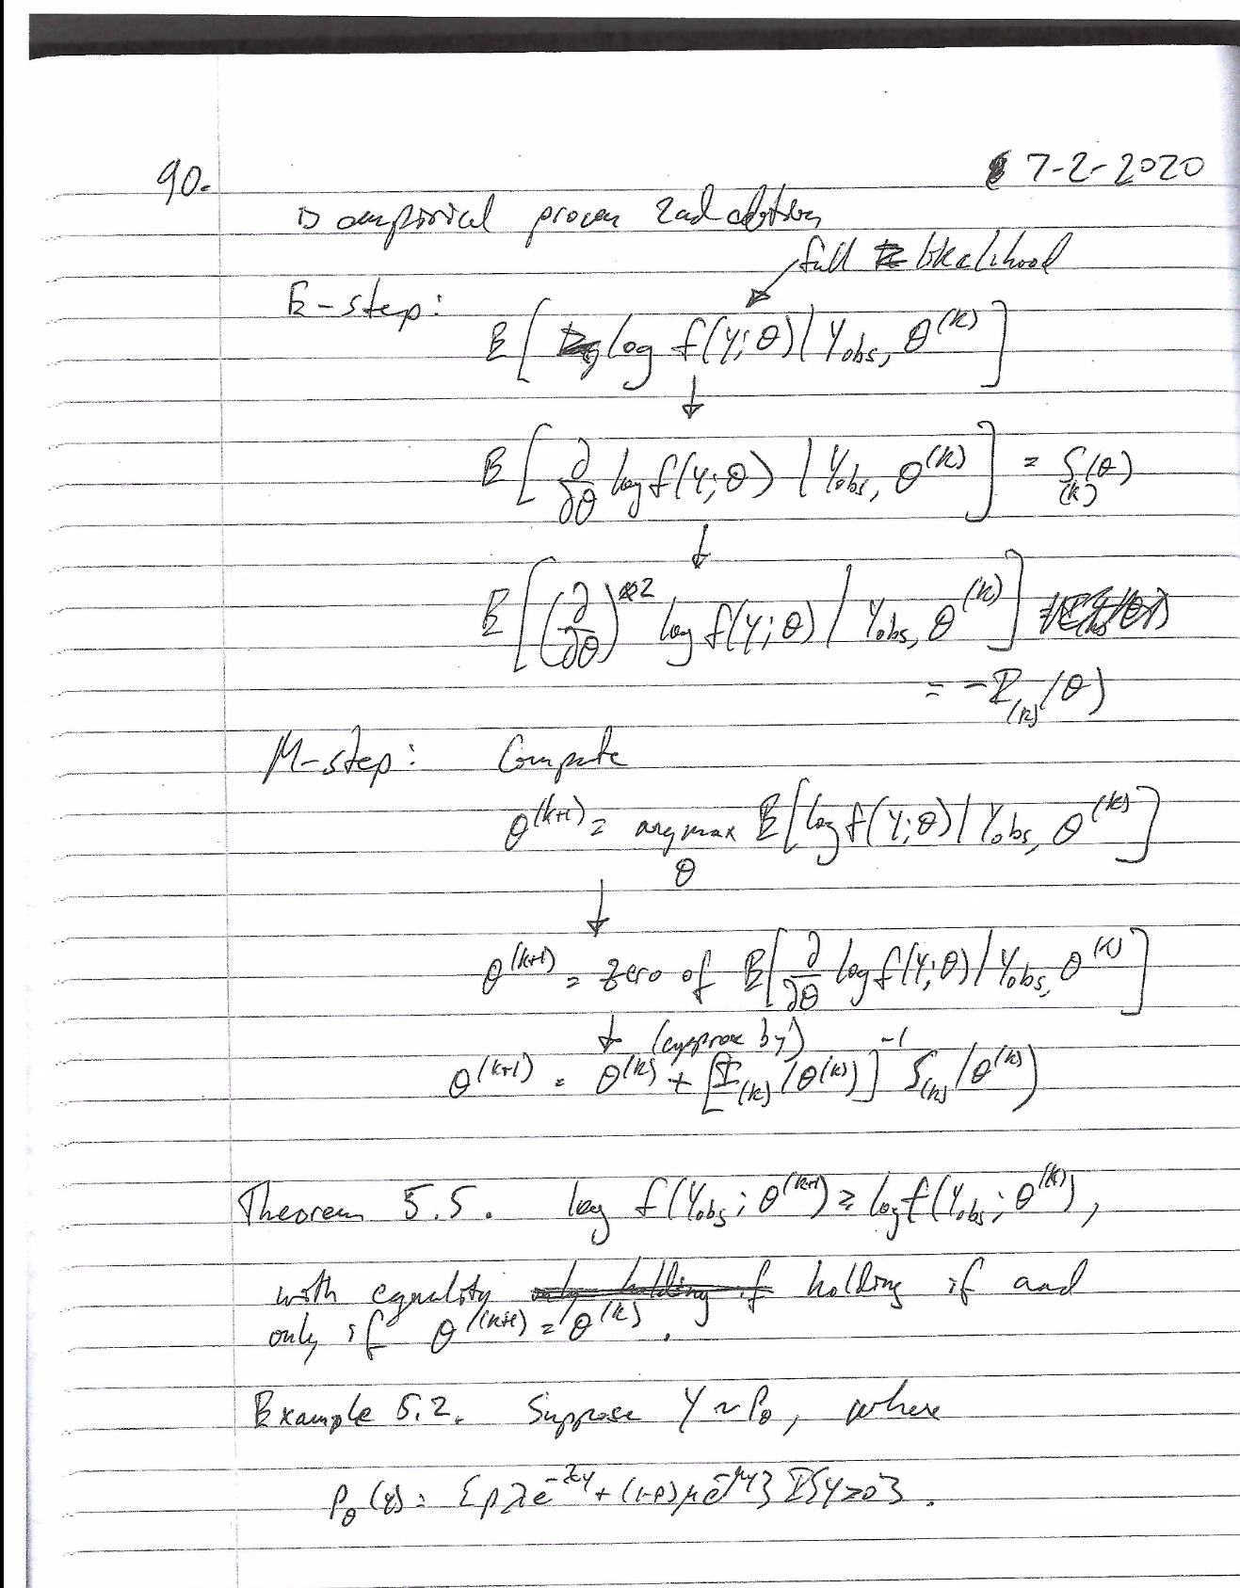

Example 5.2 is a mixed distribution. One has parameter lambda and one has parameter mu. The likelihood in this case is super difficult. EM is famously strong for working with mixture models.

Assume that you know another random variable, delta, which tells you where this mixture comes from.

Use p to denote density. You need to be able to integrate over the new variable. If I sum over the values of delta, I exactly get what I had before. So I know when I integrate (sum) over the new parameter, everything is fine. The book has you complete the score and information, but I am showing a slightly different way that they get at the answer from the book, which purifies the E and M a bit.

When I do E and M steps, needs to be on log-likelihood scale. You get a nice linear term for the delta term, so when I take the expectation given the observed data, everything falls out. I should get something that is only a function of Y and theta_k.

We are conditioning on Y, a random quantity, but we are telling people how we are going to take that expectation using theta_k. That doesn’t mean theta_k is a random variable.

It turns out that this has a nice form. Because delta is 1 or 0, it is just the conditional probability that delta =1 given Y or theta_k. That is easy ot express the conditional likelihood.

Alex: Where did the ratio for the expectation come from?

Answer: We know that P(Y|X) = P(X,Y)/integral(P(X,Y)dx)

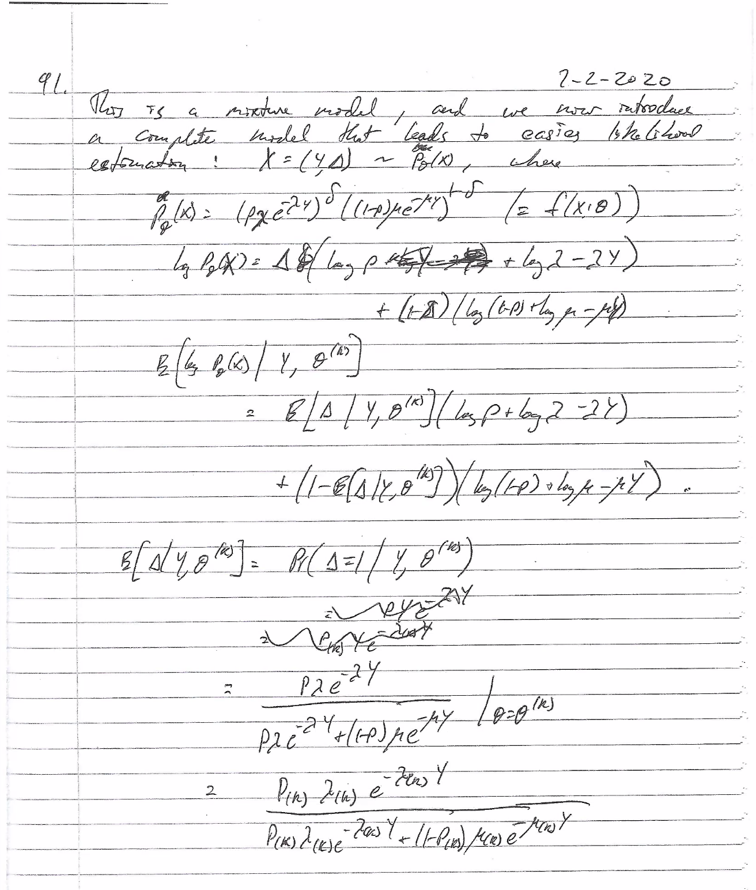

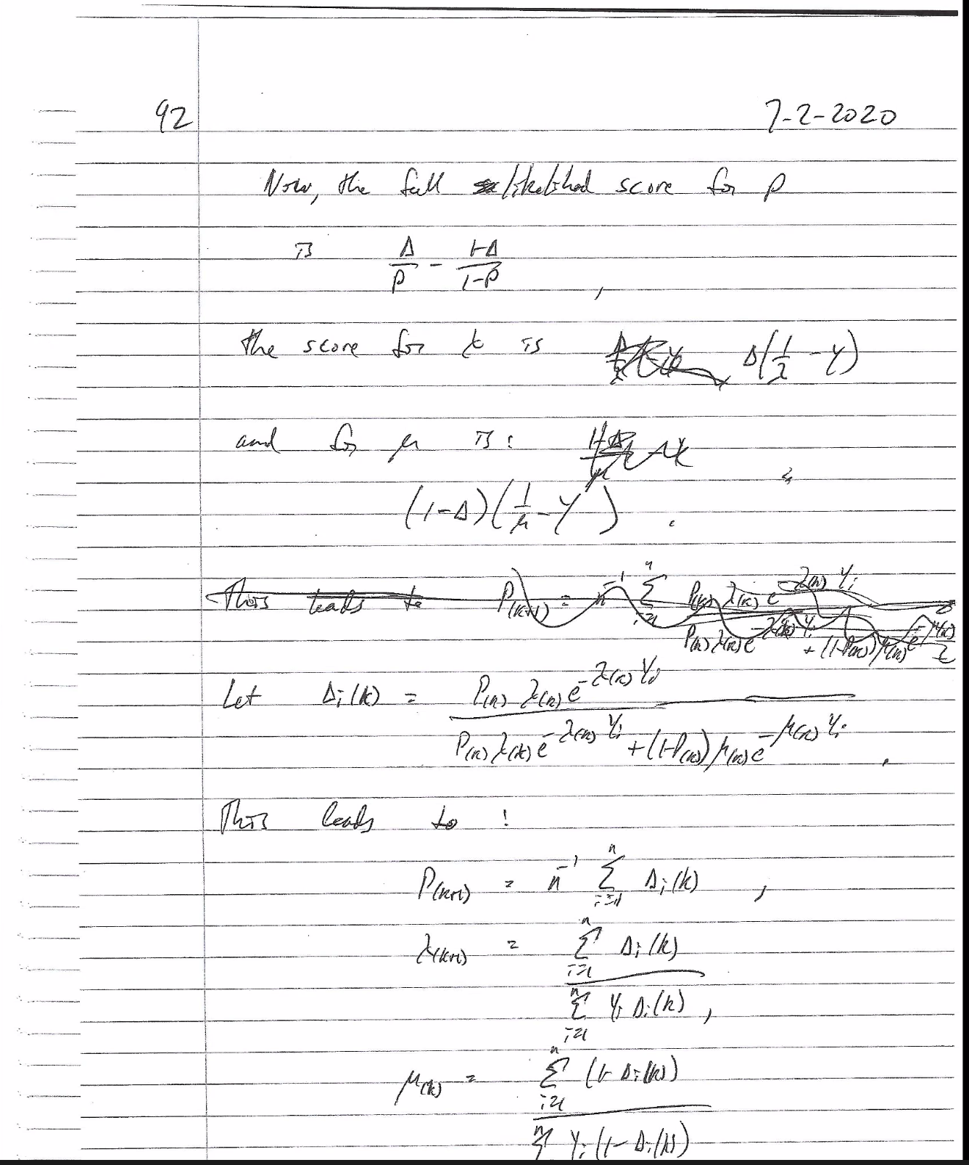

Note: Delta_i=expectation of delta given Y and theta_k

**Review of Taylor Expansion and Delta Method:**

Make sure you check for differentiability when looking at likelihoods (e.g., uniform(0,theta))!

For delta method, assume g conts differentiable and theta not 0 (theta=0 is trivial).

Recall:

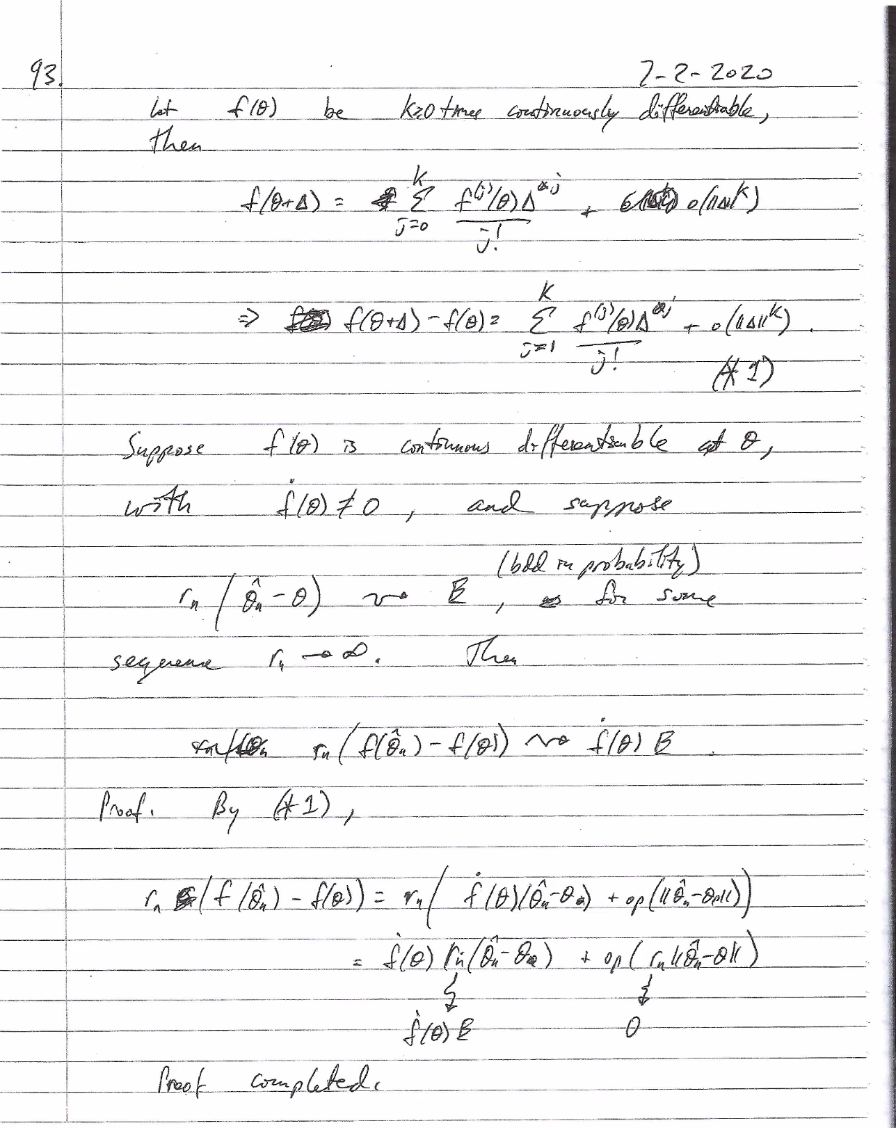

n*Xbar^2 converges to Z^2 by CMT.

